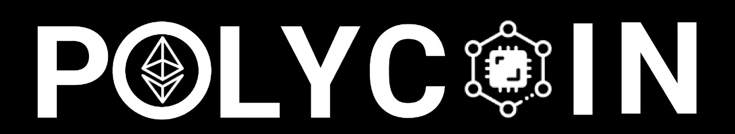

**BY: EcoVanguard**

At the forefront in the war against pollution and a step to a greener earth

1. INTRODUCTION 1

2. GENERAL OVERVIEW 1

2.1. General Overview: 1

2.2. Assumptions 1

2.3. Constraints 1

2.4. Risks 1

3. DESIGN CONSIDERATIONS 1

3.1. Goals and Guidelines 1

3.2. Development Methods 1

4. SYSTEM DESIGN 1

4.1. Technical Architecture 1

4.2. Modules 1

4.3. Relationship between Modules 1

5. SYSTEM PERSPECTIVE, USER GROUPS 1

5.1. System Perspective 1

5.2. User Groups 1

6. SCOPE 1

6.1. In Scope 1

6.2. Out of Scope 1

7. PROCESS DESIGN 1

7.1. Current Process 1

7.2. Proposed Process 1

8. UI 1

# INTRODUCTION

* Plastic pollution is a global crisis that threatens marine ecosystems, wildlife, and human health. Our system seeks to address this urgent issue by promoting plastic collection, recycling, and sustainable practices.
* The devastating impact of plastic pollution includes:

1. Ocean Life degradation: Millions of marine animals die each year due to ingesting or becoming entangled in plastic waste.
2. Ecosystem Disruption: Plastic debris disrupts marine ecosystems, affecting everything from coral reefs to plankton populations.
3. Human Health: Microplastics enter our food chain, potentially harming human health.
4. Our solution leverages blockchain technology to create a circular economy, rewarding plastic collectors, manufacturers, and investors for their positive contributions.

# GENERAL OVERVIEW

## General Overview:

* + Our platform connects plastic collectors, recycling stations, plastic producers, and investors.
  + It operates on the Ethereum blockchain, ensuring transparency, security, and decentralization.
  + Users earn tokens for collecting and recycling plastic.

## Assumptions

* We assume that plastic collectors can efficiently collect plastic waste.
* Plastic-producing companies are willing to purchase recycled plastic.
* Investors are interested in supporting environmental initiatives.

## Constraints

* Scalability: Ethereum’s congestion may impact transaction speed and costs.
* Energy Consumption: Blockchain mining consumes energy; we aim for a balance between rewards and environmental impact.

## Risks

* Regulatory Uncertainty: Blockchain regulations vary globally.
* Market Volatility: Token values can fluctuate significantly.
* Adoption Challenges: Convincing stakeholders to participate may be difficult initially.

# DESIGN CONSIDERATIONS

## Goals and Guidelines

* The system prioritizes speed, memory efficiency, and a minimalist design. Coding guidelines adhere to best practices for maintainability and readability

## Development Methods

* The design follows an object-oriented approach, incorporating structured design principles. Contingencies are considered for possible interface agreements with outside agencies or unstable architectures.

# SYSTEM DESIGN

## Technical Architecture

* backend
  + 1. solidity
* frontend
  + 1. html
    2. CSS
    3. JavaScript
* tools used
  + 1. Graph for querying
    2. deployed on Base Sepolia

## Modules

* Recycler Module
* innovator/ordering Module

## Relationship between Modules

* innovators: Place order to recycler module. Exchanged are order details
* Recycler: Gives tokens to collector
* liquidity pool: Implement the market for trading tokens
* Market: Trade tokens

# SYSTEM PERSPECTIVE, USER GROUPS

## System Perspective

* innovators: Place order to recycler module. Exchanged are order details
* Recycler: Gives tokens to collector
* liquidity pool: Implement the market for trading tokens
* Market: Trade tokens

## User Groups

* plastic collector
* investor
* innovators

# SCOPE

## In Scope

* Plastic Collection and Recycling: Designing a system for plastic collectors to pick up plastic waste. Creating a mechanism for plastic collectors to earn tokens. Integrating with recycling stations to process collected plastic.
* Liquidity Pool and Token Management: Implementing a liquidity pool where users can exchange tokens for Ethereum (ETH). Managing token creation based on the weight of recycled plastic.
* Plastic Producers’ Participation: Facilitating orders from plastic-producing companies for recycled plastic. Ensuring seamless transactions between producers and recycling stations.
* Investor Interaction: Allowing investors to purchase tokens from the blockchain market. Providing real-time token value tracking through a graph.
* Monitoring and Reporting: Building a reporting system to track plastic collection, recycling, and token flow. Monitoring environmental impact and plastic waste reduction.

## Out of Scope

* Physical Plastic Collection Infrastructure: The physical setup of plastic collection points or logistics (e.g., bins, trucks) is beyond the app’s scope.
* Blockchain Scalability Solutions: While we acknowledge Ethereum’s congestion, developing scalability solutions (e.g., layer 2 solutions) is not part of this project.
* Consumer Behavior Change: Encouraging consumers to reduce plastic use or dispose of it responsibly is not directly addressed.
* Legal and Regulatory Compliance: Legal aspects, permits, and compliance with local regulations are out of scope.
* Detailed UI/UX Design: High-fidelity UI/UX design and user testing are not part of this initial scope.
* Marketing and Outreach: Promoting the app, engaging stakeholders, and marketing efforts are not covered.
* Advanced Machine Learning or AI Models: While we use blockchain, complex AI models for plastic detection are not in scope.

# PROCESS DESIGN

## Current Process

* PlasticBank is a social enterprise revolutionizing the global circular supply chain for recycled ocean-bound plastic. It is a for-profit social enterprise founded and based in Vancouver, British Columbia, that builds recycling ecosystems in under-developed communities in an effort to fight both plastic pollution in oceans, as well as high poverty levels in developing countries.
* The company allows people living in poverty to collect plastic and trade it for goods and services including groceries, school tuition, medical insurance, pharmaceutical access, internet access, and cooking fuel, with the aim of adding more benefits to their program in the future.
* This is contrasted to our system EcoVanguard, where plastic collected can be used to earn tokens that can be traded to earn currency in the form of Ethereum coins.
* PlasticBank reprocesses collected plastics for reintroduction into the supply chain. They currently have operations in the Philippines, Indonesia, Brazil, and Egypt, with plans to expand into Colombia and Vietnam in the coming years.
* According to the company’s Sustainability Report (2022), PlasticBank had collected over 29 million kilograms of plastic waste (an equivalent of 1 billion plastic bottles) from the oceans, over 817 collection branches across different countries.
* Community Impact:
* Over 17,000 collection members in Haiti, the Philippines, Indonesia, Brazil, and Egypt have been empowered through premiums for collected plastic, aiding in necessities like groceries and education.
* Additionally, the company had made the following significant impacts on the community:
  + Active Collection Members: 21,791
  + Bonuses Paid: USD 2,181,671
  + Work Insurance: 2,539 people
  + Health Insurance: 5,600 people
  + Meal Vouchers: 2,896 people
  + Connectivity: 496 mobile phones & data packages
  + School Programs: 851 children
* The collected material is transformed into Social Plastic, an ethically recovered resource that re-enters the global supply chain, creating new products and reducing ocean plastic.
* Global Partnerships: Companies like SC Johnson, Henkel, and Coca-Cola have supported Plastic Bank’s efforts, promoted a regenerative plastics economy and enhanced the welfare of coastal communities.
* PlasticBank stands as a beacon of transformative change, leading the charge against ocean plastic pollution while fostering social empowerment. Their vision is a world where the value of plastic is fully realized, acting as a currency that enriches the lives of the vulnerable and protects our precious marine ecosystems. Through the collective effort of our global partners and dedicated community members, PlasticBank aims to expand our impact, creating a regenerative, inclusive economy where every piece of plastic collected is a step towards a cleaner ocean and a better future for all

## Proposed Process

* Recycler collects plastic
* Takes to recycling center
* Recycler awards tokens
* Innovator makes order for plastics
* Recycler accepts order
* Innovator marks order as delivered

PROCESS FLOW DIAGRAM

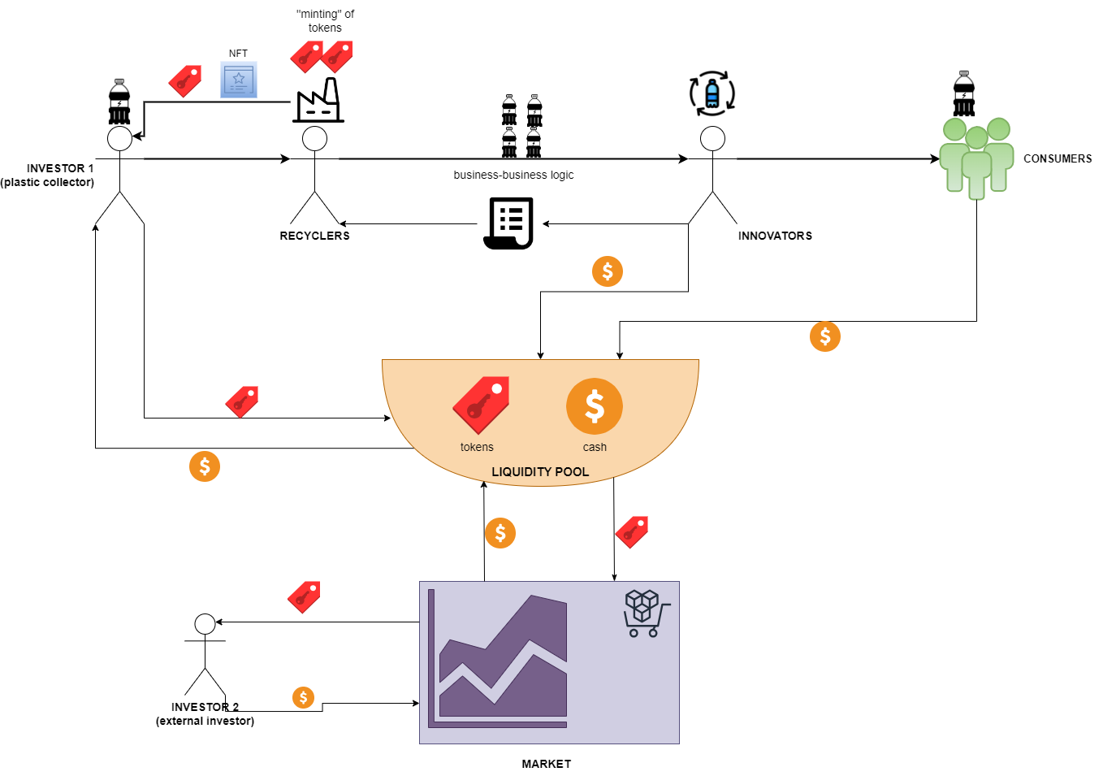

UML

f